jQuery Assignment

jQuery-- 1. Query is a fast, small, and feature-rich JavaScript library.
2. It makes things like HTML document traversal and manipulation, event handling, animation, and Ajax much simpler with an easy-to-use API that works across a multitude of browsers.

Ques. 1 Console "Hello Word" in document.ready function.

Ans 1. document.ready function-- A page can't be manipulated safely until the document is "ready". jQuery detects this state of readiness for you. Code included inside $( document ).ready() will only run once the page Document Object Model (DOM) is ready for JavaScript code execute.

<!DOCTYPE html>
<html>
<head>
<title>Question No.1</title>
</head>
<script src="https://ajax.googleapis.com/ajax/libs/jquery/3.3.1/jquery.min.js"></script>
<script>
$(document).ready(function()
{
console.log("Hello World")
});
</script>
<body>
<p>Open Console For Output!!</p>
</body>
</html>

Output:

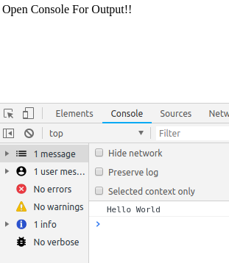

Ques 2. Select a ID name "#test" and add class "load" when DOM is loaded.

Ans 2. DOM-- Document Object Model
DOM is basically the heirarchy in html.

Code-- <!DOCTYPE html>
<html>
<head>
<title>Question No.2</title>
<style type="text/css">
.load{
background-color: red;
color: white;
}
</style>
</head>
<body>
<div id="test">
<p>I AM ID</p>
<p>NEW CLASS NAMED "LOAD" IS ADDED BY USING TEST ID</p>
</div>
<script src="https://ajax.googleapis.com/ajax/libs/jquery/3.1.1/jquery.min.js"></script>
<script>
$(document).ready(function() {
$("#test").addClass('load');
});
</script>
</body>
</html>

Output--

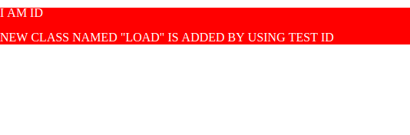

Ques 3. Change the color of element which class name end with "-new".

Ans 3. In this ques we have used hover functionality to change the the color of the class.
Hover-- The hover() method specifies two functions to run when the mouse pointer hovers over the selected elements.

Code--
<!DOCTYPE html>
<html>
<head>
<script src="https://ajax.googleapis.com/ajax/libs/jquery/3.1.1/jquery.min.js"></script>
<script>

$(document).ready(function(){
$(".sdnew").hover(function(){
$(this).css("background-color", "yellow");
}, function(){
$(this).css("background-color", "blue");
});
});
</script>
<title>Question No 3</title>
<style type="text/css">
.sdnew{
background-color: blue;
color: white;
}
</style>
</head>
<body>
<div class="sdnew">
<p>this is a paragraph</p>
</div>
</body>
</html>
Output--

(i)Before hover--
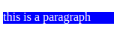

(ii)After hover--

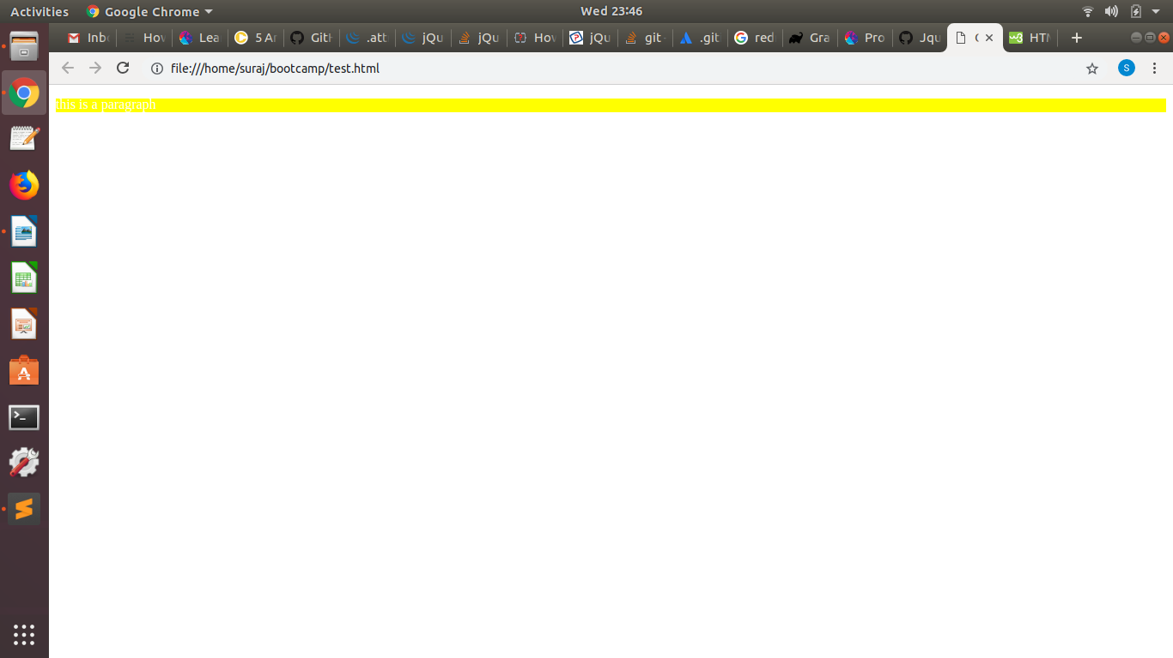

Ques 4. Disable submit button using jquery attr method.

Ans 4. attr() method-- The attr() method sets or returns attributes and values of the selected elements.
When this method is used to return the attribute value, it returns the value of the FIRST matched element.
When this method is used to set attribute values, it sets one or more attribute/value pairs for the set of matched elements.
Code--
<!DOCTYPE html>
<html>
<head>
<title>Question No 4</title>
</head>
<script src="https://ajax.googleapis.com/ajax/libs/jquery/3.3.1/jquery.min.js"></script>
<script>
$(document).ready(function(){
$("button").click(function()
{
alert("disable this alert");
$("#abc1").attr('disabled','disabled');
});
});
</script>
<body>
<button id="abc1" type="button">Tap this Button to disable</button>
</body>
</html>
Output--
(i)Before disabling the button--
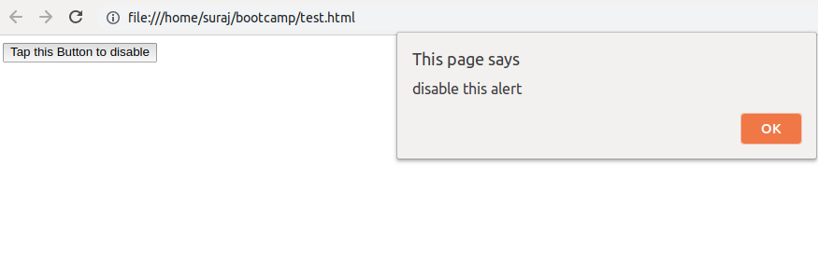

(ii)After clicking the alert()--
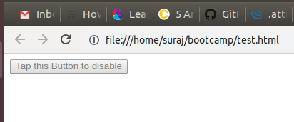

Ques 5.--Change the font size of ".target" which has parent element with id name "#main"

Ans 5.
Code--
<!DOCTYPE html>
<html>
<head>
<title>Question No 5</title>
</head>
<body>
<div id="main">
<p class="target"> I am paragraph having ID=main </p>
</div>

<div id="notmain">
<p class="target">I am paragraph having ID=notmain</p>
</div>
<button class="target">change the font of the element whose id = main</button>

<script type="text/javascript" src="https://ajax.googleapis.com/ajax/libs/jquery/3.1.1/jquery.min.js"></script>
<script>
$(document).ready(function() {
$("button").click(function() {
$(".target").parent("#main").css('font-size', '200%');
});
});
</script>
</body>
</html>

Output--

(i)Before changing font size--

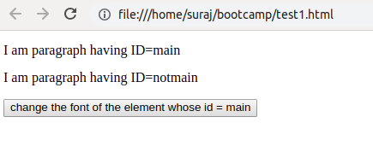

(ii)After changing the font-size--

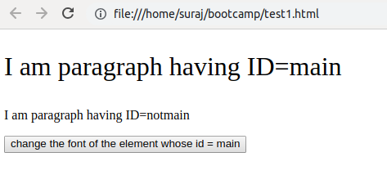

Ques 6. After page load change the HTML of div element with "p" element

Ans 6. We will use replacewith method in this question.
Replacewith()-- the replaceWith() method replaces selected elements with new content.
Code--
<!DOCTYPE html>
<html>
<head>
<title>Question No 6</title>
<script src="https://ajax.googleapis.com/ajax/libs/jquery/3.3.1/jquery.min.js"></script>
<script>
$(document).ready(function(){
$("button").click(function(){
$("div:first").replaceWith("DIVISION REPLACED WITH PARAGRAPH");
});
});
</script>
</head>
<body>
<div style="width: 50%;height: 20px;background-color: blue;">PARAGRAPH TO BE REPLACED</div><br>
<button>Replace the first p element with new text</button>
</body>
</html>

Output--

(i)Before replacing--

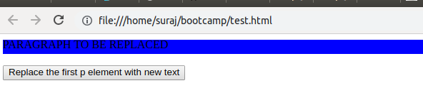
(ii)After replacing-- When clicked, the specified content will change.

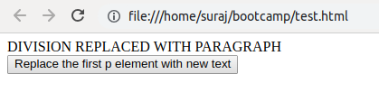

Ques 7. Bind a click function to an "click" element and append next "click" next to it.

Ans 7. Append-- The append()method inserts the specified content as the last child of each element in the jQuery collection.

Code-- <!DOCTYPE html>
<html>
<head>
<title>Question No 7</title>
<script src="https://ajax.googleapis.com/ajax/libs/jquery/3.3.1/jquery.min.js"></script>
<script>
$(document).ready(function(){
$("#btn1").click(function(){
$("body").append(" <button>Appended Next Click</button>");
});
});
</script>
</head>
<body>
<button id="btn1" type="button" onclick="function()">Click</button>
</body>
</html>

Output--

(i)Before pressing button--

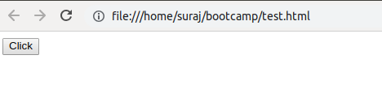

(ii)After pressing button it appends a click button next to it.--

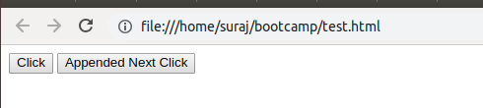

Ques 8. Click event not working on element which added dynamicly or via script, make it work using .on method

Ans 8.
Code--
<!DOCTYPE html>
<html>
<head><title>Question No 8</title>
<script
src="https://code.jquery.com/jquery-3.3.1.js"</script>
<script>
$(document).ready(function() {
$("body").append(" <b>life is awesome</b>.").on("click", function(){
alert("The paragraph was clicked.");
});
});
</script>
</head>
<body>
</body>
</html>

Output--
(i)Before Clicking--

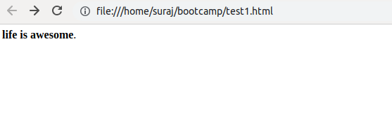
(ii)After Clicking--
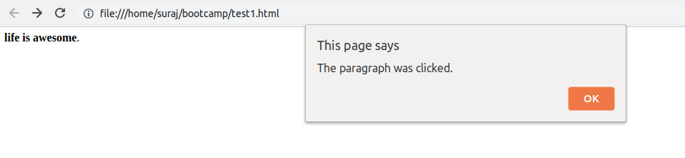
Ques 9. Get dropdown selected value on onchanage event and append in div container.

Ans 9.
Code--

<!DOCTYPE html>
<html>
<head>
<title>Question No 9</title>
<script src="https://ajax.googleapis.com/ajax/libs/jquery/3.1.1/jquery.min.js">
</script>
</head>
<body>
<select id="selector">
<option value="JVM">JVM</option>
<option value="MEAN">MEAN</option>
<option value="FEEN">FEEN</option>
<option value="IOS">IOS</option>
</select>
<div id="container"></div>
<script>
$('#selector').on('change', function() {
var el = "<p>" + $("#selector").val() + "</p>";
$("#container").append(el);
});
</script>
</body>
</html>

Output--
(i) Before Selecting--
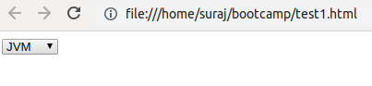

(ii)After Selecting Few, div is created and is appended in div container.--
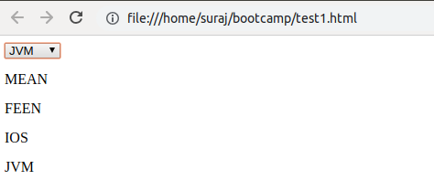

Ques 10. Create a dropdown menu using hover method in jquery.

Ans 10.
Code--
<!DOCTYPE html>
<html>
<head>
<title>Question No 10</title>
<script src="https://ajax.googleapis.com/ajax/libs/jquery/3.1.1/jquery.min.js"></script>
<script>
$(document).ready(function(){
$("#abc1").hover(function(){
$(".abc2").slideToggle("slow");
});
});
</script>

<style>
#abc1 {
padding: 5px;
background-color: #e5eecc;
border: solid 1px #c3c3c3;
}
.abc2 {
padding: 10px;
}
</style>
</head>
<body>

<div id="abc1">Hover to slide competencies</div>
<div class="abc2">JVM</div>
<div class="abc2">ANDROID</div>
<div class="abc2">MEAN</div>
<div class="abc2">FEEN</div>
</body>
</html>

Output--
(i)Before Hovering--

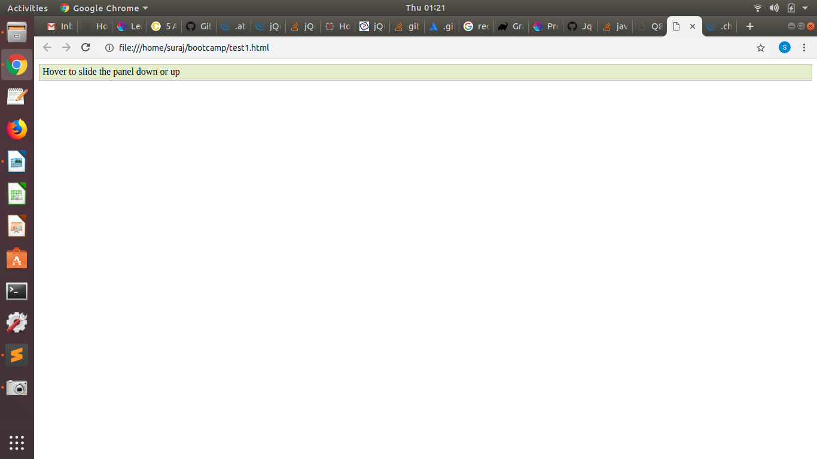

(ii)After Hovering--

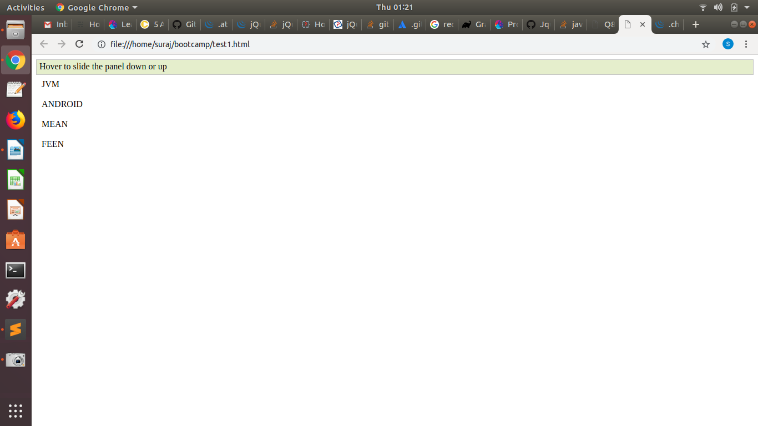
Ques 11. On clicking on "google" tag. It is taking us to google home page. Stop it from happening.

Ans 11. Using event.preventDefault function()-- It prevents the default functioning of an event performed by any function
For eg-- If there is any anchor link which takes you to the specified URL then to prevent it doing so we use event.preventDefault() .
Code--
<!DOCTYPE html>
<html>
<head>
<title>Question No 11</title>
</head>
<script>

</script>
<script src="https://ajax.googleapis.com/ajax/libs/jquery/3.3.1/jquery.min.js"></script>
<script>
$(document).ready(function(){
$(".abc1").click(function()
{

event.preventDefault();
$("p").text("Disabled button")
});
});
</script>
<body>
<a class="abc1" href="http://www.google.com">Google</a>
<p></p>
</body>
</html>

Output--
Before clicking the tag--
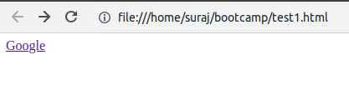

After clicking the tag it will display the message that tag is disabled--

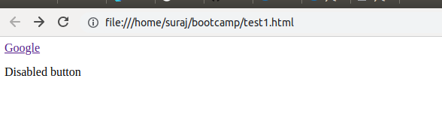

Ques 12. We have bind a click funtion to parent div but we want stop it from performing when user clicks on its child.

Ans 12.
Code-- <!DOCTYPE html>
<html>
<head>
<title>Question No 12</title>
</head>
<script src="https://ajax.googleapis.com/ajax/libs/jquery/3.3.1/jquery.min.js"></script>
<script>
$(document).ready(function(){

$("#abc1").click(function(){
alert("disable this alert");
$("#abc2").attr('disabled','disabled');
});
$("#abc2").click(function(){
alert("disable this alert");
});
});
</script>
<body>
<button id="abc1" type="button"> Parent
<button id="abc2" type="button"> Child </button>
</button>
</body>
</html>
Output-- We have created two buttons first button is parent and other is its child button
If we click on parent button it wil disable its child button and if we click its child button then it doesn’t disable parent button and displays alert same as parent.

(i)When we clicked on child button--

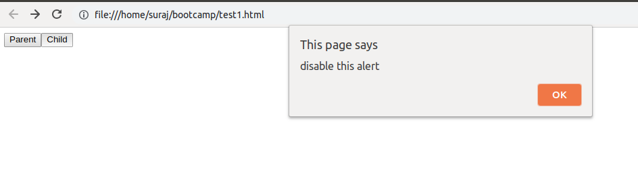

(ii)When we clicked on parent button--

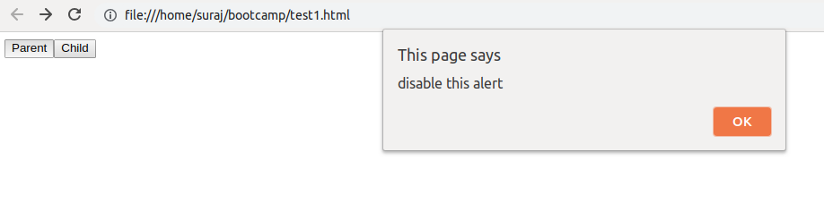
-----------------------After clciking alert() ‘OK’ Button--------------------------------------------------------

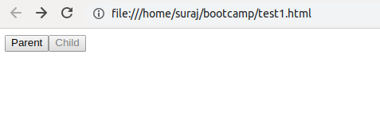

Ques 13. Get the max height of elements using jquery each method

Ans 13. We are using height method to get maximum height of the div.
Each method-- The each() method specifies a function to run for each matched element
Code-- <!DOCTYPE html>
<html>
<head>
<title>Question No 13</title>
</head>
<script type="text/javascript">

</script>
<script src="https://ajax.googleapis.com/ajax/libs/jquery/3.3.1/jquery.min.js"></script>
<script>
$(document).ready(function(){
var h=0
$(".line1").each(function(){
h=h>$(this).height() ? h : $(this).height()
});
console.log(h);
});
</script>
<body>
<div class="line1"> <br>
line1
<div class="line1"><br>
line2
line2
<div class="line1"><br>
line3
line3
line3
<div class="line1"><br>
line4
line4
line4
line4
<div class="line1"><br>
line5
line5
line5
line5
line5
line5
</div>
</div>
</div>
</div>
</div>
</body>
</html>

Output--

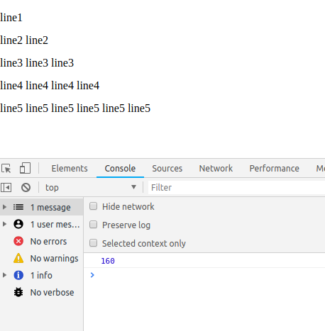

Ques. 14 Chagne color of every cell which has number larger than 10.

Ans 14.
Code--

<!DOCTYPE html>
<html>
<head><title>Question No 14</title>
<script src="https://ajax.googleapis.com/ajax/libs/jquery/3.1.1/jquery.min.js"></script>
</head>
<body>
<div class="q">0</div>
<div class="q">11</div>
<div class="q">2</div>
<div class="q">22</div>
<div class="q">3</div>
<div class="q">33</div>
<div class="q">4</div>
<div class="q">44</div>
<div class="q">5</div>
<script>
$(document).ready(function () {

$(".q").each(function() {
var el = $(this);
var value = parseFloat(el.text());
if (value > 10) {
el
.css("font-weight", "bold")
.css("color", "red");

} else {
el.css("font-weight", "normal");
}
});

});
</script>
</body>
</html>

Output--

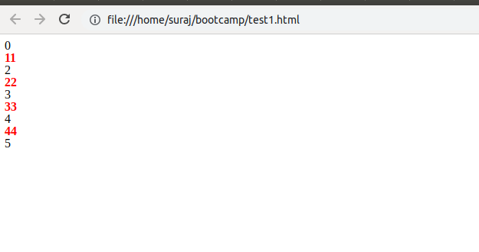

Ques. 15 Retreive the data from server using ajax get call

Ans 15.
Code--
<!DOCTYPE html>
<html>
<head>
<title>Question No 15</title>
</head>
<body>
<script src="https://ajax.googleapis.com/ajax/libs/jquery/3.3.1/jquery.min.js"></script>
<script>
$(document).ready(function(){
$("button").click(function() {
$.ajax({type: "GET", url: "https://www.reqres.in/api/users?page=2", success: function(result) {
$("div").text(JSON.stringify(result));
}});
});
});

</script>
<button>Click here</button>
<br>
<br>
<div>

</div>
</body>
</html>

Output--

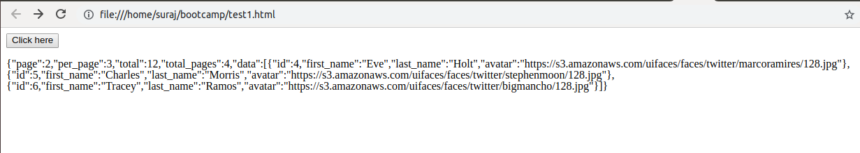

Ques 16.Add cross button on row and bind click function which make a delete request to server, after success event remove the row from dom.
Ans 16.
Code--
<!DOCTYPE html>
<html>
<head>
<title>Question No 16</title>
<meta charset="UTF-8">
<script src="https://ajax.googleapis.com/ajax/libs/jquery/3.1.1/jquery.min.js"></script>
</head>
<body>

<div id="div1">Hello, Please check console</div>
<table ><tr> <button type="button">cross button</button></tr></table>

<script>
$(document).ready(function()
{
console.log("Welcome to Console,hello");
$("button").click(function()
{

$.ajax({url:"https://www.reqres.in/api/users/2",success:function(result) {
setTimeout(function(){
console.log(result);
$('#div1').append('</br>'+result);
$('button').remove();
$('table tr').append('</br>button removed');
},1000);

},error:function(){

}});
console.log("outside ajax");

});
});

</script>
</body>
</html>

Output--
(i)Before clicking cross button

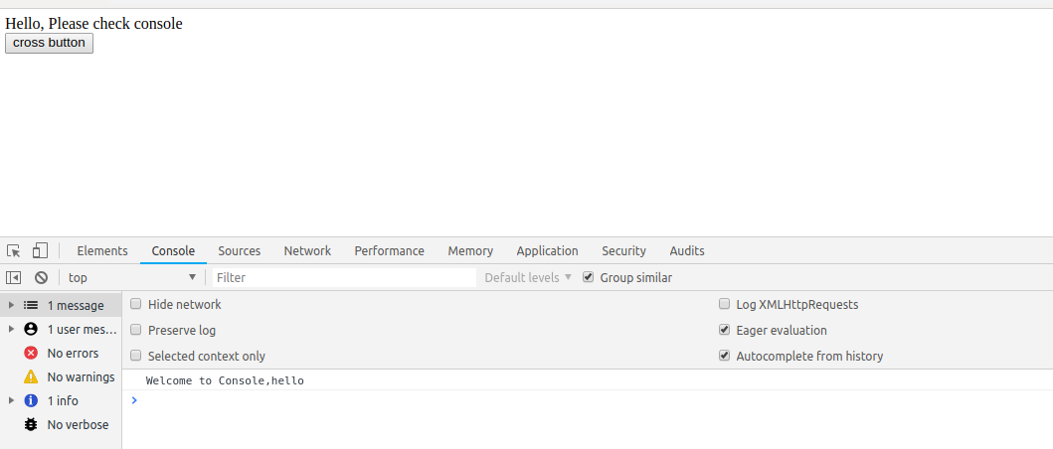

(ii)After clicking cross button

